Delete Account page Design document

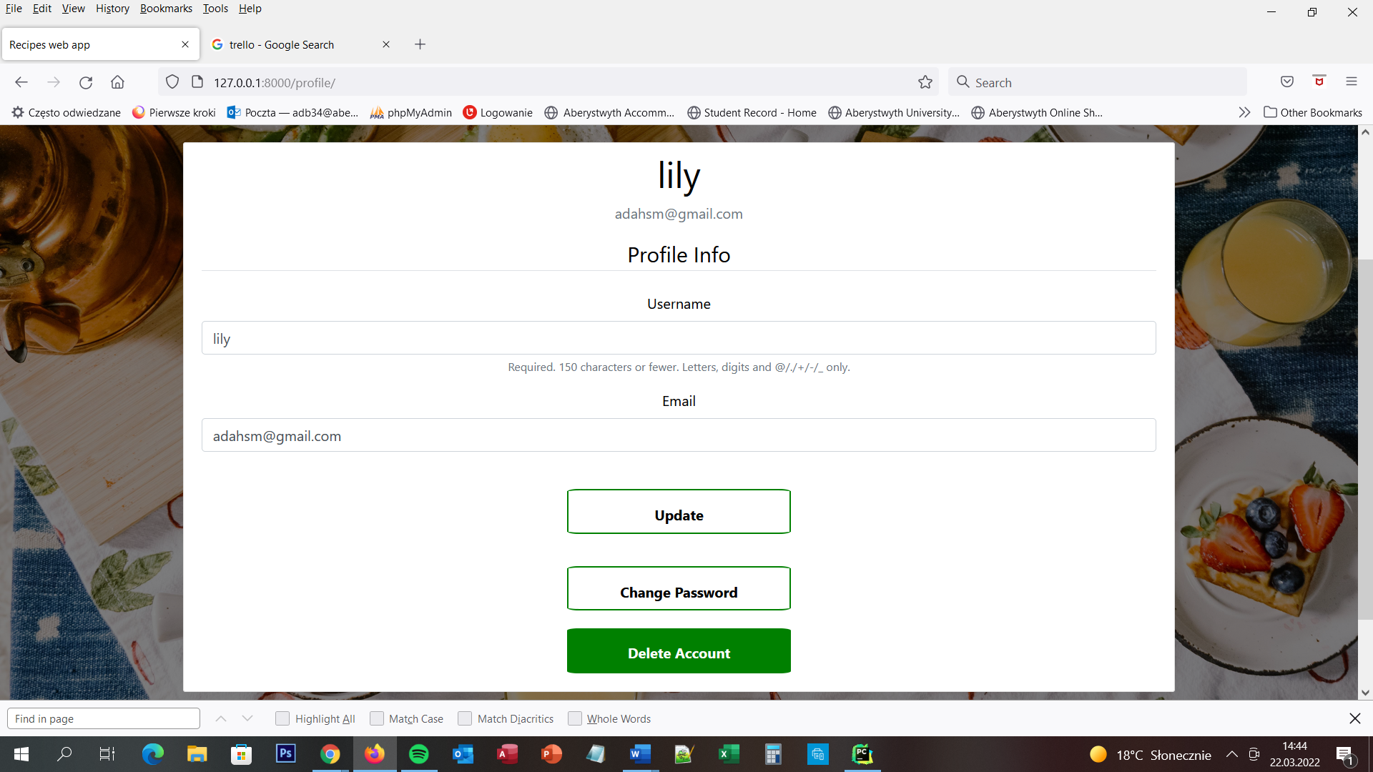

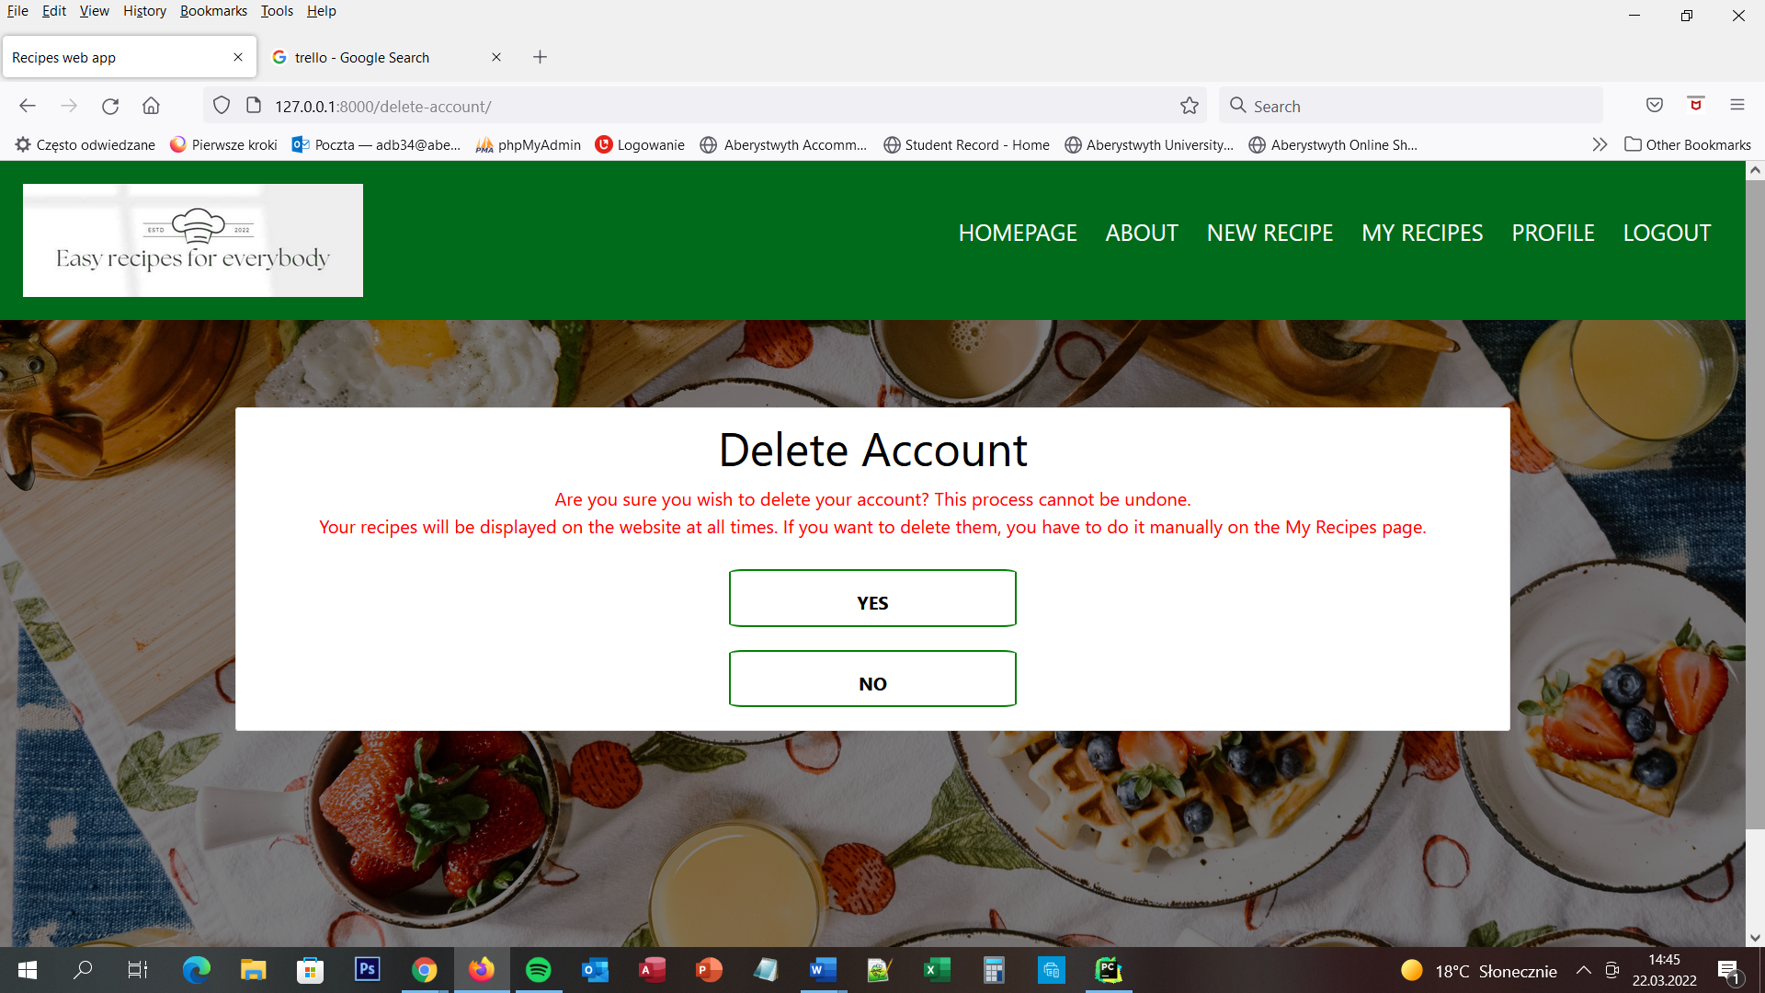

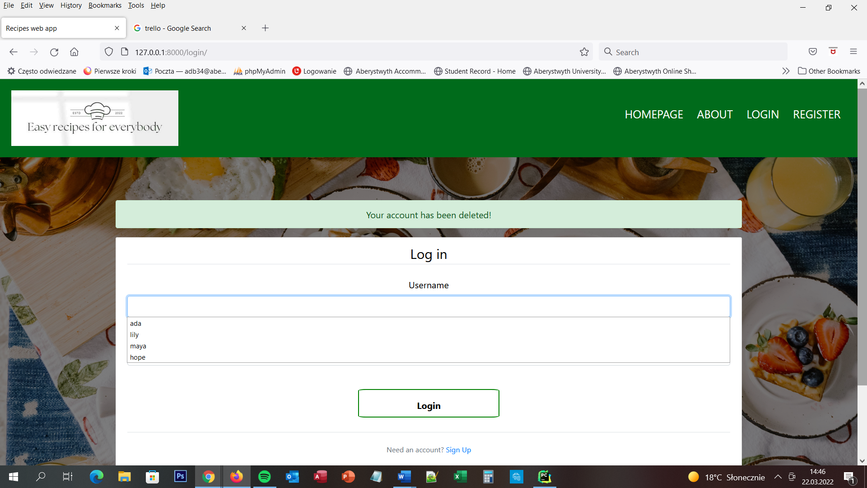

## Delete account page

When the user is successfully logged in to the website he/she is able to delete his/her own account. The user needs to go to Profile Page and then click the button DELETE ACCOUNT. After this, he/she is moved to the Delete account page. On the top of the screen, the user is able to see a navigation menu bar with six buttons and the website logo. All of the buttons are moving the user to the dedicated pages. On the screen user is able to see the message – Are you sure you wish to delete your account? This process cannot be undone. Your recipes will be displayed on the website at all times. If you want to delete them, you have to do it manually on the My Recipes page. – and two buttons – YES and NO. Button NO is moving ser to the Profile page again and button YES is deleting the user account and moving the user to Login Page.

## URL diagram

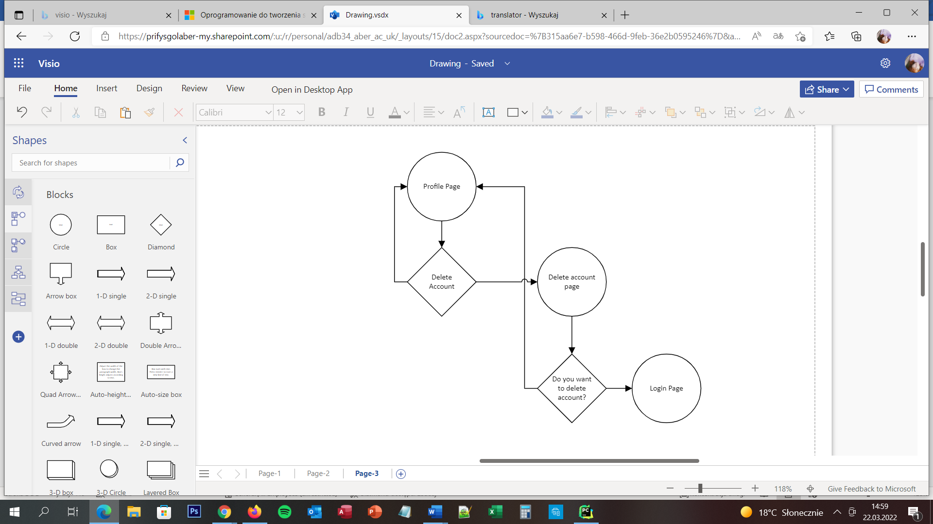

NO

NO

YES

YES

## User Story

User is able to delete the account only when he/she is successfully logged in to the website and he/she will go to Profile Page. When the user does that he/she pressed the button Delete Account and the user is moving to Delete Account Page. Then he/she needs to answer the question - Are you sure you wish to delete your account? This process cannot be undone. Your recipes will be displayed on the website at all times. If you want to delete them, you have to do it manually on the My Recipes page. If the user wants to delete all recipes too, he/she needs to press button NO and go to My Recipes Page and delete each of the recipes manually and then come back to Profile Page, press button – Delete Account and after he/she is moving to Delete Account Page, user needs to press button YES. If the user wants to leave all of the recipes on the website, he/she can press the button YES right away.

## Acceptance Criteria

The page should display the message, two buttons and a navigation menu. Each button should be clearly named. Seven of eight buttons should move the user to the connecting pages:

* Homepage to homepage
* About to about page
* New recipes to Add recipe page
* My recipes to my recipes page
* Profile page should reload the page
* Logout to Logout page
* NO to Recipe Page

YES button should change value active next to the user who wants to delete the account and then the user is no longer able to login to the website. After the user pressed it he/she should be moved to Login page and ultimately log out from the website.

## User interface – Pseudo code

The Delete Account page appears for the user when he/she is successfully logged in to the website and after he/she went to the profile page and he/she pressed the button – Delete Account. On the client-side is to press the button YES or NO. On the server-side is when the user press button NO – move him to the profile page, when user press YES – logout him from the page, change the active value in the database to false next to his/her username and move the user to Login page.